IOT BASED TRAFFIC MANAGEMENT

PHASE 5 PROJECT

SUBMITTED BY

Name : R SUNDAR

Nan mudhalvan ID : au713921106052

Email ID : rsundar042004@gmail.com

INTRODUCTION

The wide variety of motors on the street has risen dramaticallyin current years. Congestion is a growing trouble that everybody offers with on an everyday basis. Manual site visitors manage through site visitors law enforcement officials has now no longer established to be effective. A version is designed to efficiently clear up the above noted troubles through the usage of Internet of Things (IOT). A community ofsensors is hired to hint the quantity of motors and the site visitors congestion on the intersections on a road, and rerouting can be primarily based totally at the site visitors density at theroute's lanes.

A clever city's site visitors control device is essential. In the modern troubles of the world, city mobility is one of the most important troubles, mainly in metropolitan cities. Previous webpage site visitors manipulate systems had been now not as lots because the venture of dealing with the growth in web page sitevisitors on the roads. The purpose of this take a look at is to advise an Internet of Things-primarily based totally clever site visitors control device and a decentralized method to optimize site visitors at the roads and shrewd algorithms to control all site visitors conditions extra due. The faults of in advance site visitors control structures are addressed on this counseled device. The approach makes use of site visitors density facts from cameras that has been abstracted. As an end result of the Digital Image Processing generation and sensor facts, the output is sign administrated.

CODE:

```cppconst int mainRoadRedPin = 2;const int mainRoadGreenPin = 3;const int sideRoadRedPin = 4;const int sideRoadGreenPin = 5;const int mainRoadSensorPin = 6;const int sideRoadSensorPin = 7;void setup() {pinMode(mainRoadRedPin, OUTPUT);pinMode(mainRoadGreenPin, OUTPUT);pinMode(sideRoadRedPin, OUTPUT);pinMode(sideRoadGreenPin, OUTPUT);pinMode(mainRoadSensorPin, INPUT_PULLUP);pinMode(sideRoadSensorPin, INPUT_PULLUP);}void loop() {// Check if there are vehicles on the main roadif (digitalRead(mainRoadSensorPin) == LOW) {// Main road has vehicles, so stop side road trafficdigitalWrite(mainRoadRedPin, LOW);digitalWrite(mainRoadGreenPin, HIGH);digitalWrite(sideRoadRedPin, HIGH);digitalWrite(sideRoadGreenPin, LOW);} else if (digitalRead(sideRoadSensorPin) == LOW) {// Side road has vehicles, so stop main road trafficdigitalWrite(mainRoadRedPin, HIGH);digitalWrite(mainRoadGreenPin, LOW);digitalWrite(sideRoadRedPin, LOW);digitalWrite(sideRoadGreenPin, HIGH);} else {// No vehicles, all lights are red (4-way stop)digitalWrite(mainRoadRedPin, LOW);digitalWrite(mainRoadGreenPin, HIGH);digitalWrite(sideRoadRedPin, LOW);digitalWrite(sideRoadGreenPin, HIGH);}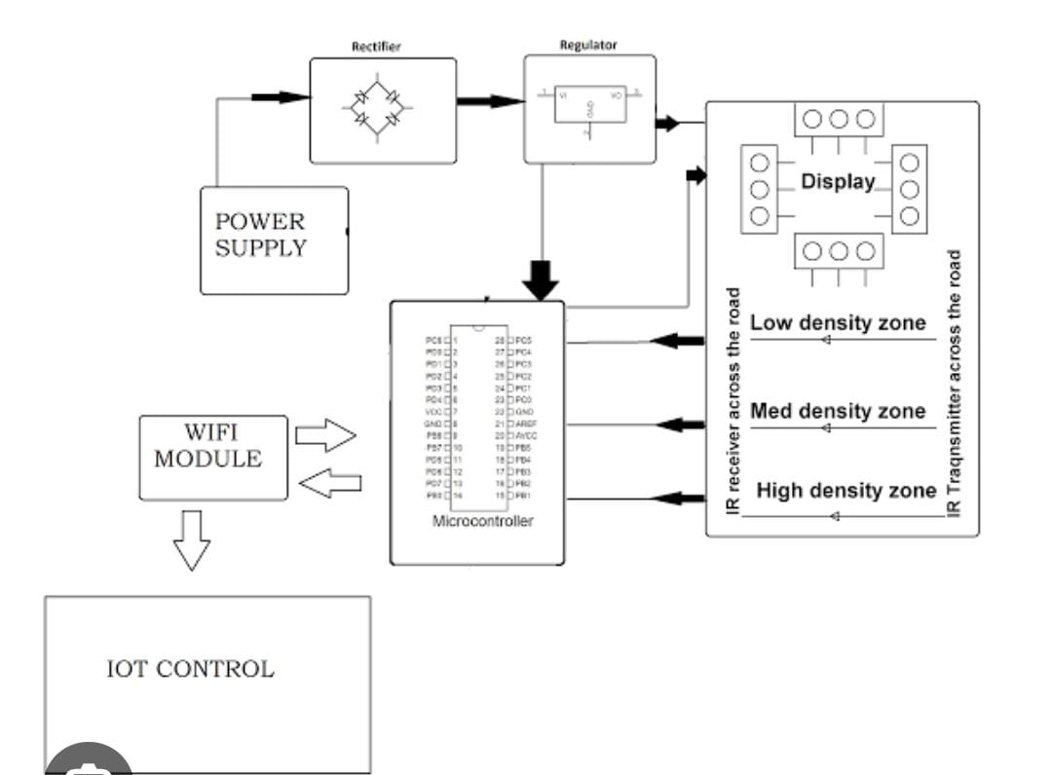

## Smart Traffic Management System Goals

– Prioritize moderate traffic conditions by analyzing real-time traffic situations.

– Providing congestion-free traffic.

– Improvising traditional ticketing with an automated E-bill payment system.

– Speed sensors to warn commuters about speed violations.

– Provide a smart lighting system that reserves renewable energy sources.

– Offer safe and punctual public transportation.

– Eradicate pollution.

– Advanced traffic monitoring systems at intersections and narrow road end to provide the right traffic guidance through GPS and GIS.

– Optimizing road networking systems, through building IoT, enabling quick and better communication systems.

## Integrating Intelligence to Monitor and Manage Traffic

AI and big data components have the potential to change the way how traffic monitoring and traffic control systems work in the present scenario.

## **IoT for Smart Traffic Control**

The drawback of having a predefined time-based signaling system in many cities is that the traffic management system functions irrespective of traffic flow. And the responsive smart traffic control systems act according to real-time traffic conditions. Below mentioned are the components of a smart traffic control system-

**1. A central control system**: The central control system acts as a base of a traffic control system. This system is integrated with traffic lights, signals, cameras, and queue detectors. The AI-based system can analyze real-time data by collecting information from the computer vision-enabled 3d AI cameras and queue detectors. The AI system helps in passing on optimized information to control the functioning of the traffic lights and signals for the free flow of traffic.

**2. Smart signal lights**: Smart traffic lights and signals reduce the inefficiencies in traffic congestion and idle time at intersections. The intelligent lights can manage the queue and clear the traffic irrespective of the predefined timing system.

**3. Intelligent cameras and queue systems**: The cameras and queue system updates information to the control system about real-time traffic condition. And the control system enacts this real-time information to clear the overcrowding traffic and helps in reducing pollution.

## **How do Smart Traffic Control Systems Work?**

1.AI integrated big data tools and IoT-enabled intelligent communication systems are integral parts of smart traffic monitoring systems. And the tech components that define the smart traffic monitoring system are traffic lights, smart roads, public transportation, smart parking, and a geospatial traffic guidance system. These systems replace traditional ticketing systems with automation by providing advanced assistance through IoT-enabled communications. Services by integrating sensors, vehicle-mounted information systems, and private individual vehicle tracking devices for tracing commuter locations.

2. Smart roads and smart highways are developing tech applications of AI. The roads and highways are equipped with sensors that monitor vehicle speed and inform the vehicle owners through vehicle-mounted information systems regarding speed over the limit, penalties, and information regarding overhead traffic. Smart parking enables access to information through an app or mobile application regarding vacant parking lots at a particular location for better assistance.

3. Geospatial traffic guidance system is an integration of GIS, GPS, and radiofrequency devices. It provides 3d visualization of real-time geographical data based on the position of a physical object. GPS is currently used to detect the best routes to reach particular destinations within less time based on the traffic in all possible pathways. Geospatial technology can advance this system by providing guidance, on possible upcoming obstacles, and traffic inflows from various routes and their respective queue length

## **Features of a Smart Traffic Management System**

The key features are listed below depending on the city’s size and the scope of the governmental policies. It can be integrated into an intelligent traffic management system. They include:

**Traffic Jam Detection:** With cloud connectivity, sensors, and CCTV cameras tracking intersections 24×7, technicians can remotely monitor all the streets in real-time from the city’s traffic control room.

**Connected Vehicles:** A smart traffic system using IoT technology can connect with roadside tracking devices to enable direct communication between intelligent vehicles & intersections.

**Modular Control:** Real-time detection of congestion triggers dynamic adjustments in the systems meant for controlling traffic lights, express lanes, and entry alarms.

**Emergency Navigation:** A system with edge data processing & programmatic alerting capabilities can alert response units (police, ambulance & tow trucks) in case of a car crash or collision. It reduces the crucial time an injured driver or passenger remains unattended.

**Road Safety Analytics:** Systems with pattern detection capabilities can immediately flag high cruising speeds and reckless driver or inappropriate pedestrian behavior.

**Digital Payments:** Commercial traffic management systems enable quick and convenient electronic transactions in real time while ensuring financial data safety.

## **. ITMS Applications**

Here covers a wide range of ITMS applications that all serve to highlight the effects of video-based network vehicle monitoring systems, including environmental impact assessment, safety monitoring, and Traffic Signal Control Systems.

**Anomaly detection**: [Traffic congestion](https://encyclopedia.pub/entry/11782) and vehicle accidents are both made more likely by driving in a way that is against the law. The use of video surveillance allows for the detection and enforcement of a variety of driving offenses, including taking an incorrect turn and failing to stop at a red light. Rajeshwari et al. [[8](https://encyclopedia.pub/entry/42004#ref_8)] presented a survey article in which numerous techniques to manage and locate vehicle accidents on a street using a surveillance camera are examined, and the research also includes a brief assessment of various autonomous road and street accident detection methodologies.

**Security**: A network-based surveillance system can record a vehicle’s trajectory across the road network to track a specific vehicle of interest. In combination with online streaming of real-time video, this technology helps law enforcement agencies benefit from monitoring and preventing criminal activity. By addressing the issue related to security, Fedotov et al. [[9](https://encyclopedia.pub/entry/42004#ref_9)] discussed a method based on the processing of video and audio that is going to be used in an effort to determine whether people have committed crimes. This will trigger an alarm at the nearby surveillance station, which may already be in control of a large number of CCTV images from neighboring places. The security personnel who are responsible for keeping an eye on multiple screens at the same time will find this to be beneficial.

**The collection of vehicle tolls**: The planning, execution, and dissemination of information concerning the autonomous operation of the vehicle selection system are the primary focuses of the ITMS. The vehicle toll collection device locates passing vehicles and compiles toll data that can be read by video sensors that detect the features of a vehicle, particularly its license plate number, as it passes through charging ports such as highway exits and entrances or parking lots. Nowadays, RFID-based toll systems [[10](https://encyclopedia.pub/entry/42004#ref_10)] are used for collecting tolls without human intervention.